Setting up Jupyter Lab

Mac:

Anaconda:

Installation:

1. Use link below to download ‘Anaconda’ Mac executable. ‘Download’ under ‘Anaconda Distribution’

<https://www.anaconda.com/products/distribution#macos>

1. Click on executable file ‘Anaconda3-2022.10-MacOSX-x86_64.pkg’
2. Proceed through dialog box to install.
3. Finder -> Applications -> Anaconda Navigator. That will open new window
4. ‘Environments’ tab to search for and install packages/environments.
5. Under ‘Jupyter Lab’ select ‘Launch’ to open.
6. Open ‘Python 3 (ipykernel)’ underneath ‘Notebook’ option to load Jupyter Notebook session.

Windows:

Anaconda:

Installation:

1. Use link below to download Anaconda executable. ‘Download’ underneath ‘Anaconda Distribution’

<https://www.anaconda.com/products/distribution#windows>

1. This will download file ‘Anaconda3-2022.10-Windows-x86_64.exe’ to your ‘Downloads’ folder
2. Double click on file ‘Anaconda3-2022.10-Windows-x86_64.exe’ from above step.
3. Proceed through dialog box options to install.
4. Open start menu, expand ‘Anaconda3’ -> Anaconda Navigator. That will open new window
5. ‘Environments’ tab to search for and install packages/environments.
6. Under ‘Jupyter Lab’ select ‘Launch’ to open
7. Open ‘Python 3 (ipykernel)’ underneath ‘Notebook’ option to load Jupyter Notebook session.

Using Jupyter Lab & Notebook:

1. Open ‘Python 3 (ipykernel)’ underneath ‘Notebook’ option to load Jupyter Notebook session.
2. Description: Jupyter provides a web-based interactive computing platform where we can use code, narrative text, equations and visualizations. It will allow us to practice python programming. Throughout a notebook, you will see cells starting with ‘In [ ]:’
3. You can write code inside a cell by clicking inside the box to select it. When we write code in it, we can run by clicking the run button on the top that looks like a play button or keyboard shortcut Shift + Enter.

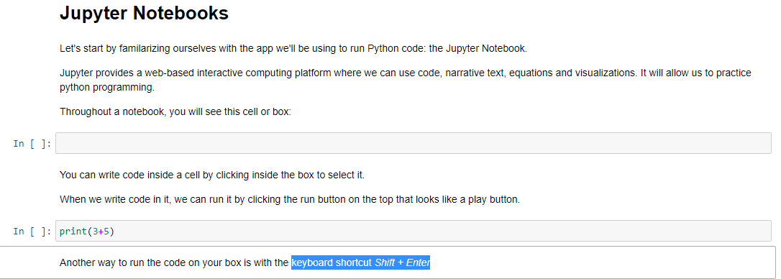

Installing Python Packages to Jupyter Lab:

1. Open terminal. Inside Jupyter lab, File -> New -> Terminal
2. Depending on which installation method you performed above will determine how to install packages.

Anaconda:

conda install ‘package_name’

ex: conda install pandas

System:

pip install ‘package_name’

ex: pip install pandas

Saving Jupyter Notebooks

1. Inside Jupyter lab, File -> New -> Notebook
2. ‘File -> Save as -> provide name for new file. This will be stored and visible in menu every time you open jupyter lab moving forward.
3. To download. Open Notebook file. File ->